Script Formación Repositorio
- Introduction + what is the IE Repository (1min 10s)

Objective: Explain what the repository is and why it matters.
Good morning everyone,
and thank you for joining today.
Let’s begin with a quick overview of what the IE Repository is and why it matters.
The IE Repository is the institutional open access platform that collects, manages, and preserves all the academic and scientific work produced at IE University.
Its mission is to increase the visibility and impact of IE’s research community, while ensuring compliance with open access requirements and institutional policies.
By sharing your work in the repository, you contribute to transparency, accessibility, and the global dissemination of knowledge — helping research reach further and have greater impact.
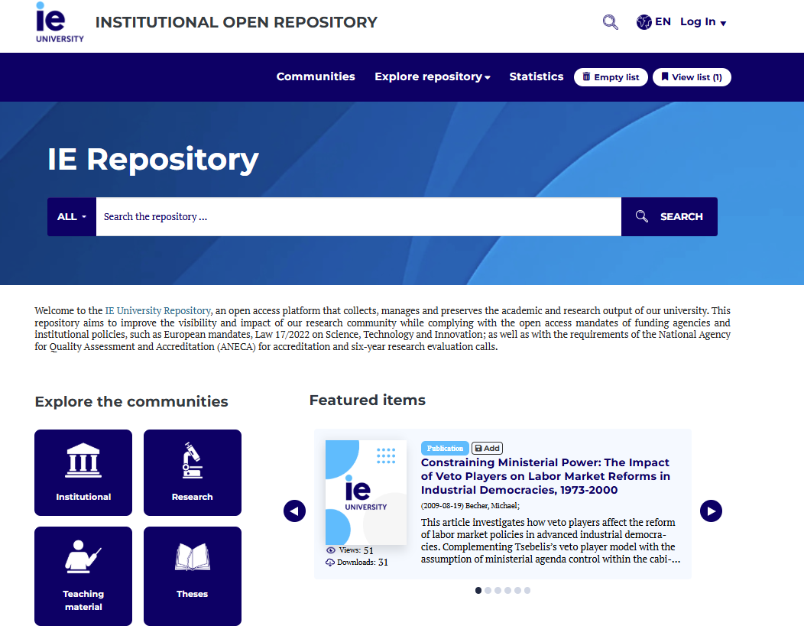

- What can be uploaded (1min 15s)
Objective: Describe the different types of documents accepted in the repository.
The repository includes different communities that group materials by type or purpose.
You can upload a wide variety of documents, including:
- Institutional materials, such as reports, manuals, surveys, and procedures.
- Research outputs, like journal articles, conference papers, books, working papers, reports and datasets.
- Teaching materials, including innovative projects and Open Educational Resources, or OERs.
- And finally, Doctoral theses, which are also hosted in the repository.
Together, these collections represent the academic activity and intellectual contribution of IE University.
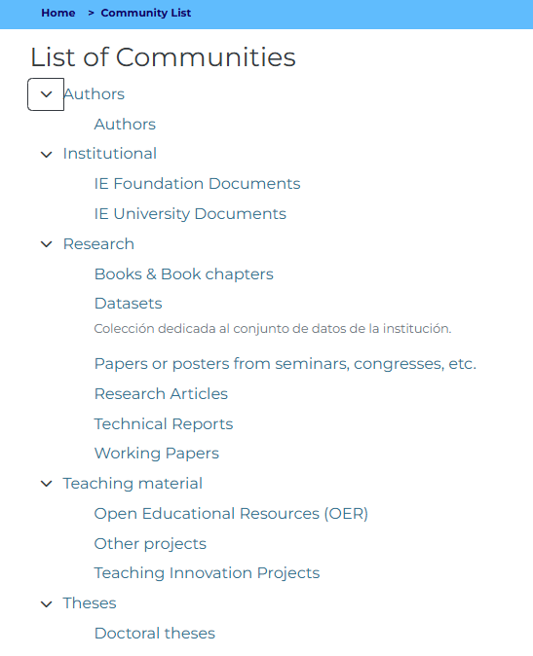
- Which version can be uploaded (1min 10s)
Objective: Clarify which document versions are eligible.
It’s very important to know which version of your document can be uploaded.
There are three main versions of a manuscript:
- Preprint – the version before peer review. Usually not accepted, except for working papers.
- Accepted version (postprint) – this is the peer-reviewed version before the publisher’s layout or formatting.
- Published version – the final, formatted version released by the journal.
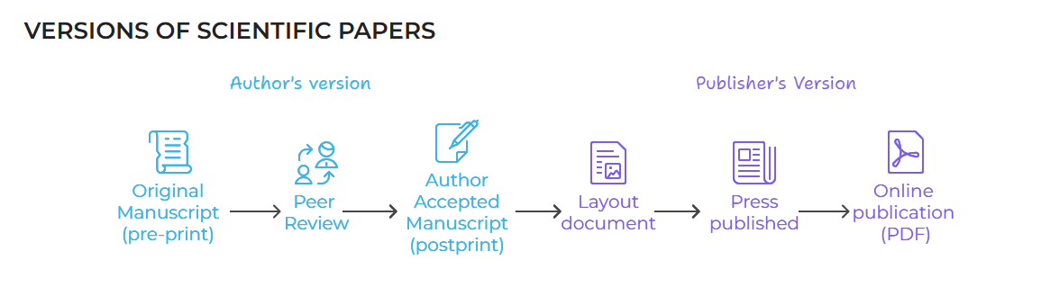
Which one you can upload depends on the publisher’s open access policy.
To check this, we use a tool called Open Policy Finder, where you can search by journal title or publisher.
It tells you which version can be deposited, whether there’s an embargo, and what license applies.
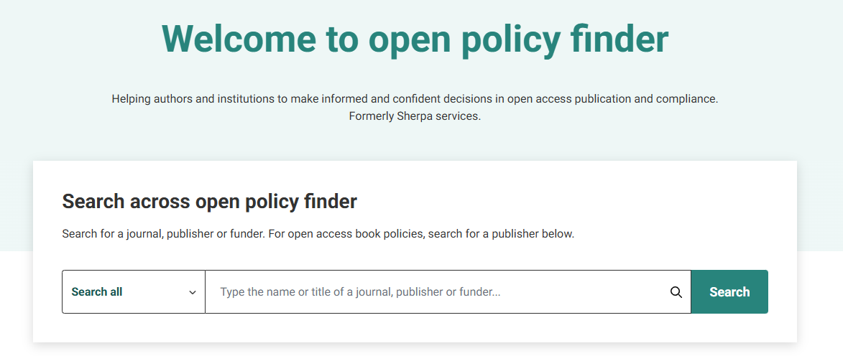
- License and access type (1min 15s)
Objective: Explain Creative Commons licenses and access options.
Every document in the repository must have a license — this defines how others can use and share your work.
In most cases, the license is determined by the publisher or by the journal’s open access policy.
If your publication already includes a license, that one will be kept when uploading to the repository.
If the publication doesn’t specify one — for example, in the case of reports, presentations, or theses — you can choose a Creative Commons license.
Each license combines one or more elements:
- BY – Attribution: users must credit you when reusing your work.
- SA – Share Alike: derivative works must carry the same license.
- NC – Non-Commercial: your work cannot be used for commercial purposes.
- ND – No Derivatives: others may share your work, but not modify or adapt it.
All Creative Commons licenses require proper attribution, and you can select the combination that best fits your needs and institutional requirements.
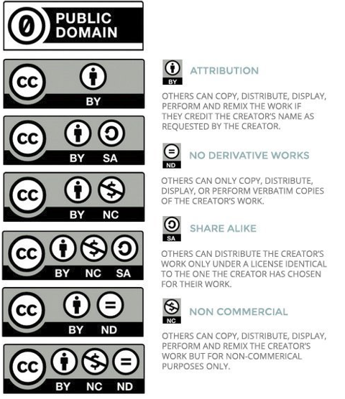
Finally, you’ll choose the type of access — open, restricted, or embargoed — depending on the publisher’s policy or funding conditions.

- How to upload to the IE Repository (2min 40s)
Objective: Provide a step-by-step guide to the submission process.
Now, let’s walk through how to upload your document step by step.
- Access the IE Repository using your IE credentials.
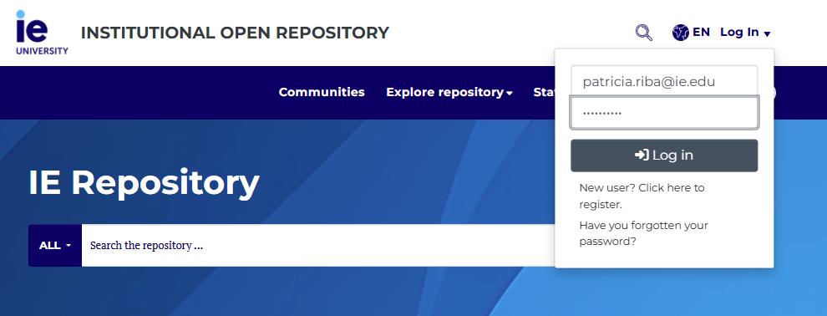
- On the main page, click the plus (+) icon > new item to start a new submission.
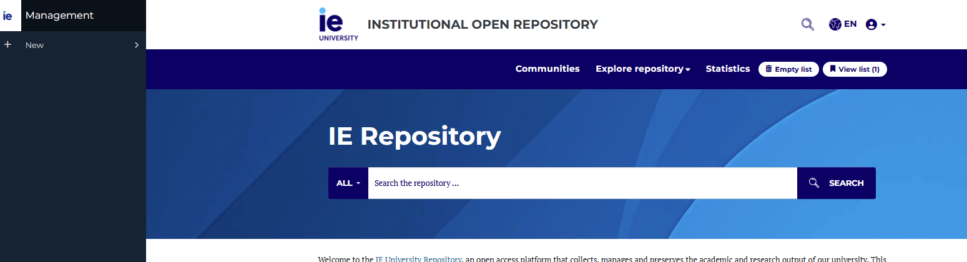
- Select the type of material you’re uploading — for example, research, teaching material, thesis, or institutional document.
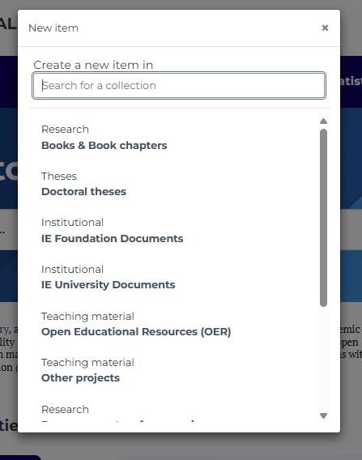
- Begin filling in the submission form. Choose the document type, school, and department.
[añadir imagen una vez estén los formularios completos]
- Add the basic information — title, author, publication date, and editors.
[añadir imagen una vez estén los formularios completos]
- Include persistent identifiers such as DOI, ISSN, or ISBN whenever available. These are essential for proper citation and linking.
[añadir imagen una vez estén los formularios completos]
- Then, complete the technical and descriptive details of your document:
add the number of pages, the language of the work, the recommended citation, and the document format — for example, PDF, Word, or dataset.
This information ensures consistency and accurate indexing within the repository.
[añadir imagen una vez estén los formularios completos]
- Add the abstract, keywords, and any funding or project information, including sponsor names and project IDs.
[añadir imagen una vez estén los formularios completos]
- Next, choose the license, access type, and material type.
[añadir imagen una vez estén los formularios completos]
- Attach the document file (usually in PDF format) and accept the submission terms.
[añadir imagen una vez estén los formularios completos]
- Finally, submit your document for review.
[añadir imagen una vez estén los formularios completos]
After submission, our Library team will check all metadata and file details.
If everything is correct, you’ll receive an approval email, and your work will appear in the repository shortly after.
If changes are needed — for example, a missing field or embargo issue — we’ll email you with instructions to fix it.
- Closing (45s)
Objective: Reinforce the repository’s importance and offer support.
The IE Repository helps make IE University’s research more visible, accessible, and impactful.
It also supports compliance with open access mandates, academic evaluations, and long-term preservation of our scholarly output.
If you have any questions or need help uploading your work, please contact the Library team — we’ll be happy to assist you.
Thank you for watching!

