Walking Memories, Future Dreams: Exploring Design through Cartographies, Speculation and AI

Abstract
This paper summarizes a design practice (“Take the Memory Out for a Future Walk”) conducted with undergraduate students in a park in Barcelona. Through walking, sensory mapping, artificial intelligence exploration, and prototyping, participants explored the interplay between embodied experiences, memory, future speculation, and design intervention. Walking the park fostered sensory engagement, shaping students' understanding of the site and its history. This informed the development of projects addressing environmental concerns and promoting sustainable practices through reimagined spaces or objects. Students employed AI tools to generate ideas where they envisioned alternative futures and challenged existing norms. This process encouraged non-canonical reflection, urging students to move beyond conformistic approaches while fostering future-oriented critical thinking. The practice yielded valuable insights for design education. Firstly, it showed why the integrating walking and sensory mapping into design processes can challenge space determinism. In addition, it contributed to the potential of speculative design and future studies to foster alternative imagination and address pressing issues like climate change, promoting planetary awareness. Further iterations could benefit from expanding on-site exploration and incorporating material limitations to deepen student engagement with the natural surroundings, community and project sustainability.
Keywords: Speculative Design; Future Studies; Artificial Intelligence; Design Pedagogical Methodology, Sustainability; Cartography.

1. Introduction
“Ways of acting in the environment are also ways of perceiving it.” (Ingold, 2000, p. 9).
This study explores the “Take the Memory Out for a Future Walk” workshop, a pedagogical experiment conducted with first-year undergraduate students in the Design program at EINA University School of Design and Art of Barcelona in 2022 during the Projects I studio course. The workshop, anchored in the embodied practice of walking and the transformative power of speculative design, sought to delve into the historical memory of Barcelona's Collserola Park and envision its future possibilities 100 years hence.
Michel de Certeau (1984) reminds us that walking serves as an intervention in space, leaving no physical marks while inviting the city and nature to co-create experiences. It necessitates a deliberate slowing down, fostering appreciation of our surroundings and the value of time. As an act of exploration and imagination, walking becomes the foundation for a new design approach, one which denotes the subjective visceral inner happenings of the individual. This workshop embraced this philosophy, and its main purpose was to present an interdisciplinary methodology to design new solutions to urgent sustainable real-world challenges fostering a deep interconnection with nature and all living organisms. It also aimed to:

- Stimulate critical reflection: Encourage students to reflect on the park's historical memory and envision its future possibilities amidst climate change and other uncertainties.
- Embrace embodied methodologies: Integrate walking and sensory cartography as design tools to enhance spatial, contextual, and proprioceptive awareness.
- Foster connections with nature: Address and explore the perceptual breadth of space and cultivate a deeper appreciation for immediate natural spaces, to promote responsible stewardship for the environment.
- Challenge with speculative design and future thinking: Introduce students to methods for imagining alternative futures, urging them to embrace uncertainties and generate flexible design solutions.
- Explore artificial intelligence's creative potential: Introduce and experiment with artificial intelligence (AI) tools like Dall-e and Midjourney to enhance future visioning and design exploration.

The methodology aimed to transcend disciplinary boundaries, weaving together art, design, ecology, earth science, and technology. Through dedicated walks within chosen territories, students drew sensory cartographies that captured the spatial essence. Engaging with AI tools, they then generated diverse future hypotheses and design possibilities. These explorations resulted in proposals that ranged from spaces and maps to relational objects in face of climate emergency, all informed by the affective encounters with the site. By analyzing the theoretical framework, methodology, and outcomes, we unveil the power of sensory exploration and speculative design in reimagining living spaces and fostering critical engagement with the non-human world.

1.1 Collserola Park: Urban Oasis Under Pressure
The Serra de Collserola Natural Park, sprawling across 8,000 hectares of Barcelona, embodies a paradox: an ecological and scenic treasure entangled with urban densification. This “lung” of the city, boasting immense biodiversity and bridging the city-nature divide, faces growing challenges. Despite its vast green expanse, the park houses a railway station, buildings, roads, and schools (including the university where this workshop took place), attracting a surge of recreational visitors. While providing much-needed recreation, this influx intensifies stress on the ecosystem. Soil erosion, wildlife disturbance, waste generation, noise pollution, and extreme drought (Busto and Yzaguirre, 2024) paint a worrying picture.
Traditionally, addressing these issues has focused on informing the public about causes, impacts, and solutions. However, research by Abrahamse and Matthies (2012) suggests mere information provision falls short in driving behavioral change. This park, therefore, presents a compelling case study for exploring design-driven solutions. Graphic, spatial, and product design, used strategically, could transform information into a powerful tool for shifting how people interact with the park. This necessitates innovative, engaging approaches that foster pro-environmental behavior and mitigate environmental damage. By harnessing the power of design in the age of the Anthropocene (Merchant, 2020; Morton, 2021), we can breathe new life into this urban oasis, ensuring its ecological splendor endures for generations to come.

2. Theoretical Background
2.1 Walking and Perceiving to Create Affective Atmospheres
“But the dérive includes both this letting-go and its necessary contradiction: the domination of psychogeographical variations by the knowledge and calculation of their possibilities.” (Débord, 1981)

Our globalized lives tend to numb our senses, disconnect us from our surroundings, and damage the environment. Subtle interventions like walking (Certeau, 1984) and more proactive initiatives like tactical urbanism (Lydon and Garcia, 2015) showcase the potential of citizens to creatively shape their urban spaces. Building on this, Catalan psychiatrist Francesc Tosquelles (1947) emphasized the cognitive power of walking, suggesting that it is not the head that counts, but the feet. He advocated for collecting the intuitions gathered through walking, viewing it as a cultural heritage inscribed in both natural landscapes and the anatomy of the places we traverse. On another side, Guy Débord created the Situationist technique known as the dérive (drifting), which involves aimlessly and unstructurally exploring cities, guided not by typical reasons like work or leisure, but by the inherent allure of the surroundings and their psychological and creative impacts (1981). This concept, although akin to the flâneur, is shaped by urban studies, particularly the work of Henri Lefebvre (as cited by Evans, 2013).
More recently, Ingold (2000) challenges the concept of a global environment as a unifying force, arguing instead that it represents the culmination of human separation from the world. This separation stems from our tendency to observe events from a distance, rather than actively experiencing them. This points to the critical distinction between “local” and “global” perspectives. Localness isn't simply a narrower view; it represents an engaged, perceptual interaction with the components of our inhabited world, not a detached observation. Architect and theorist Juhani Pallasmaa states that "despite the profusion of materials, forms and goods, our industrialized cultural environment seems to be increasingly impoverished in terms of experience and feeling." (Pallasmaa, 2009). Furthermore, Heidegger, in his essay 'The Thing', reinforced that science and technology were still insufficient to help people make sense of their worldly experiences. (as cited by Portella, 2024). It was his theory of closeness or 'coming to nearness from distance' that is essential to man's understanding of his lifeworld.
From this experiential standpoint, our understanding deepens as we immerse ourselves in the world, seeking knowledge and meaning. It is through this attentive engagement, inherent in the act of dwelling, that the world progressively reveals itself to us (Ingold, 2000, pp. 214-216). The connection between our mental representation of space and movement is well-documented. Ingold cites Gibson's ecological psychology, emphasizing that we perceive the world through a “path of observation” (2010). Our perception of atmospheres isn't forged by moving from a limited local view to a panoramic global one. It is rather through transitioning from one place to another, experiencing shifting horizons and engaging with our affective spheres (Sumarjoto and Pink, 2019), the emotional reaction to changes in place and environment.

2.2 Drawing Sensory and Cognitive Maps
“The map is not a total inventory; in a sense, it is a work of art (although the drawing is not drawing). It is precisely and intuitively plotted.” (Deligny, as cited by Alves and Pérez, 2018, p. 587)

The more we move through a space, the more we comprehend it as a coherent whole, not just a collection of separate elements. This not only enhances navigation but also fosters deeper engagement, leading to appropriation and alternative forms of spatial production. This workshop explored how drawing and design can intertwine with walking, creating a cyclical process of creation, analysis, and knowledge generation. Drawing allows us to perceive our environments and produce mental images, both in our minds and in the physical world. In an experience of reciprocity (Bullen, Fox and Lyon, 2016), the act of drawing becomes an act of discovery (Berger, 2005). Moreover, the act of drawing enables us to “understand the essential structure of forms, to organize an inventory of things, and, through their operational knowledge, to design and produce new objects of our culture” (Gómez Molina et al, 2005, p. 162). The imperfection of viscerally responsive trace offers the “happy accident” or may indicate a certain ephemeral or material quality that can take you on a journey of the imagination.
According to Smith, hand-made drawings can be informal, rough and with ill-defined marks, imbued with the errors of humanity (2016). The casual disorder or the unexpected, such as the stain of a piece of charcoal pressed with force, the persistent erasures of a dirty eraser, the traces of over-drawing or the peculiar bodily gesture are reflected in the creation. The act of drawing, pervasive across both artistic and architectural domains, assumes varied manifestations ranging from rational to emotive, contingent upon specific objectives and developmental phases. As Wolfgang Pehnt contends, drawing represents a medium uniquely predisposed to the realization of imaginary visions, evoking a process akin to a free, impassioned gesture that leaves an indelible mark (as cited by Segui, 1999).
On the other hand, maps are more than navigational tools; they are systems of signs, memories, and meanings that enable us to remember, reimagine, and appropriate spaces, fostering new social practices and making spaces feel alive. From a cognitive perspective, maps aid in spatial problem-solving (Kholina, 2019). However, traditionally hand-drawn maps were seen as a product of our brain's limitations in processing complex stimuli. Maps, mental images, and similar constructs are considered “complex, highly selective, abstract, and generalized” (Downs and Stea, 1973). They are the result of abstraction, akin to creating maps by simplifying complex environments for better navigation. By drawing our sensorial experiences and stimuli, capturing diverse patterns, behaviors, and identities, we reveal meaningful paths and connections, also supporting orientation in space: our proprioception (Skaza, 2019). Emerging research (Rossetto, 2019) proposes an ontology of oriented cartographies, framing map creation as a philosophical act, emphasizing their post-representational potential as resources for speculation, non-objectivity, and relational, affective, cultural, and sensorial objects.
Finally, we might refer to Fernand Deligny’s contribution to the field of work with maps and cartographies to explore creative strategies for psychogeography communication. As a staunch opponent of institutions of all types, he made a radical critique of positivist educational concepts and rejected the view of autism and cognitive disability as pathological deviations from a pre-existing norm. His studies incorporated contributions from anthropology and ethology into pedagogical practice. Without seeking centrality or seeking to constitute a pedagogy, Deligny’s methodology was to encourage his patients to draw cartographies there were not only produced in extension, but they were also intensities, narratives and affections: an experience of in-between, as stated by Deleuze (as cited by Alves and Pérez, 2018).

2.3 Speculative Design for Imagining Experiential Futures
“The goal of the experiential future is not simply to create interesting experiences, but to enable experiences that lead to the creation of better futures” (Candy, 2016, p. 29).

Speculative design is an approach where designers create products or objects linked to imagined scenarios of how things might be (Dunne and Raby. 2013, p. 2). These scenarios can occur in the future, alternative pasts, or even present situations. It requires people to suspend their disbelief and allow their imaginations to wander. Speculative designers Anthony Dunne and Fiona Raby draw an analogy to thought experiments, showing the shared ability of both approaches to explore possibilities through imagination. This allows us to “step outside reality for a moment to try something out” (2013, p. 80). This analogy has become widely accepted in the field of design and even extends to the realm of art. Within the realm of critical design, the speculative design practice serves to promote critical reflection among individuals. This reflection can not only generate new perspectives on current realities but also encourage people to envision their desired future. Such acts of imagination contribute to public discourse on contemporary issues like emerging technologies, climate change, and capitalism (Auger, 2013; Dunne and Raby, 2013).
As stated by Carey et al., “design futuring can engage ideas about ideals to clarify long-term possibilities in work on social change. […] When we imagine long-horizon futures, we can clarify ideas about the world we want to achieve, without detracting from it with current barriers.” (2022, p. 2). This design practice encounters a close relationship to future studies or strategic foresight, a transdisciplinary field aimed at supporting organizations and communities in mapping their future possibilities. Within this field, “experiential futures” encompass various practices that make hypothetical futures tangible, performative, interactive, and playable (Candy, 2016). These approaches in art, digital media, design, and play aim to help individuals grapple with long-term, large-scale prospects by making them more imaginable, discussable, speculative (Figure 1a).
Futures strategist and professor Joseph Voros revised the graphic, recognizing it as "an adaptation and extension" of earlier work. In 2013, Dunne & Raby streamlined the diagram and presented it to a design audience, crediting Stuart Candy for introducing them to Voros's diagram (Figure 1b). While traditional futures practices operate at a high level of abstraction, experiential works explore more concrete manifestations of possible, probable, and preferable futures (Candy, 2016). “Probable” futures inform traditional design, describing likely outcomes based on current trends. “Plausible” futures involve scenario planning and forecasting, exploring alternative possibilities through a “what if?” lens. Finally, “possible” futures venture into extreme scenarios of scientific possibility, encompassing utopias and dystopias without delving into fantasy or science fiction.

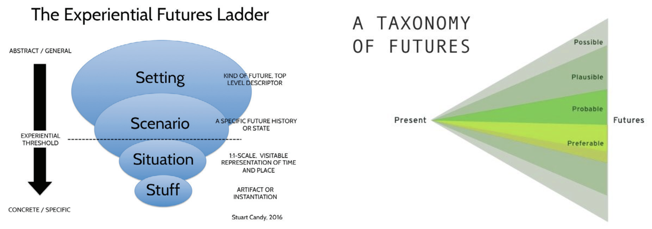
Figure 1. Most traditional futures practices operate at a high level of abstraction, while experiential work explores more concrete manifestations of futures –– possible, probable, and preferable (Candy, 2016).
However, Howell et al. draw attention to the Eurocentric foundations of the futures cone. They provide a critical perspective, emphasizing that the cone's depiction of time as purely linear and progressive neglects alternative viewpoints (as cited by Carey et al., 2022). According to Carey et al., the speculative design method, as a result, may overlook the social, political, and environmental contexts necessary for these artifacts, along with their broader implications. This perspective underscores the need for a more nuanced design process, advocating for a shift towards a more plural, inclusive and life-centered approach.
2.4 Shifting from Human towards Life-Centered Design
Historically, the evolution of human consciousness has expanded through various stages: from individualistic to tribal to national and international perspectives (Ichioka and Pawlyn, 2021). The current environmental and climate crises partly stem from our disconnect from the natural world. Since at least biblical times, humans of Abrahamic or Judeo-Christians faiths have seen themselves as separate and superior to the rest of the natural world (Berry, 1999; Merchant, 2013, 2020). This rift between humans and nature and its attendant hierarchical dualism provided the basis of a moral imperative for humans to subjugate the more-than-human world. As humans, we build cities, cultivate agriculture, and develop products and virtual media. Yet, we remain reliant on nature's resources and restorative systems, necessitating better tools for understanding and interacting with the biophysical world. Ichioka and Pawlyn defend that there is an opportunity to extend that further to a planetary perspective that sees all life on Earth as connected, and our urgent challenge is to integrate everything we do as humans into the web of life that supports us so that we can flourish within planetary limits (2021). This expansion in thinking must also embrace the way we see ourselves as humans.
This ecological challenge underlines the need for an alternative design approach that challenges the prevalent Human-Centered Design (HCD) methodologies. In response to HCD's focus solely on human needs, recent design paradigms like Life-Centered Design (LCD) or Regenerative Design have emerged to promote sustainability (Jawaharlal, 2016; Ichioka and Pawlyn, 2021). LCD is a design methodology that considers all life forms, aiming to create mutually beneficial relationships between humans and other living beings, ultimately leading to a more sustainable future. On the other hand, regenerative design is another approach in which human systems are designed to co-exist and co-evolve with natural systems, ensuring planetary and social health, by rethinking the cycles of food, energy, water and materials (Ichioka and Pawlyn, 2021). If we have moved from identifying as subjects, to consumers, to conscious consumers, we must now go further and see ourselves as citizens or “possibilists” (Ichioka and Pawlyn, 2021), actively engaged in shaping a positive future with neither the constraints of pessimism nor the false comforts of optimism.
This lens might support designers in developing methods for building speculative artifacts with rich “lifeworlds” that reflect the plurality of human experience and the systems that affect those experiences (Carey et al, 2022, p. 5). Summing up these concepts, we offered this workshop as a case study of situated, ethical design pedagogy, to critically reflect on the effectiveness of these strategies, and to find our own opportunities for transformational design learning in student work, intertwining speculative, LCD and regenerative approaches into our methodology.

3. Methodology
The workshop “Take the Memory Out for a Future Walk” spanned an interdisciplinary methodology to design new solutions to urgent sustainable real-world challenges fostering a deep interconnection with nature and all living organisms. The main question posed to the students was: “How might you envision the Collserola Park in 100 years hence through design?”. The proposal was designed for a group of 25 people (17 female students and 8 male students), aged between 17 and 23 years, during the Projects I course in the Bachelor in Design at EINA University School of Design and Art of Barcelona. The methodology was delivered in five sessions, each lasting 3 hours and 30 minutes, for a total of 18 hours and 30 minutes. The workshop started at a chosen area in Collserola Park and continued in the university’s classroom, which is located next to one of the park’s entrance.
This geographic advantage was an opportunity for students to deeper engage with nature around them. This didactic experience consists of walking around the park and carrying out different conceptual actions subsequently, all within a period of 21 days, from November 22nd to December 13th, 2022. Classes were dedicated to a set of activities that allowed students to practice and acquire the competences of the subject, being the last one the final presentation. These phases or creative actions are detailed below in four pedagogical activities (followed in chronological order): 1) sensory walks and cartographies, 2) speculating on possible futures, 3) brainstorming with AI, and 4) drawings and materialization.
It is also important to state that the element of uncertainty was a persistent factor in the methodology, due to our inability to fully control the outcomes of each of the workshop activities, leading to results that could be entirely unexpected. This lack of predictability provided a fertile ground for creative exploration and empirical learning, benefiting both the instructor and the students.

3.1 Activity #1: Sensory Walks and Cartographies
Before embarking the walk in the park, students were introduced to the project brief and subject matter, including the theory of speculative design and references of projects ranging from Anthony Dunne and Fiona Raby to contemporary design studios such as Superflux. Subsequently, the first pedagogical activity consisted on inviting students to embark on empirical explorations within the park. By interacting in situ, students were encouraged to wander meditatively, engaging in mindful observation, recording sounds, taking pictures, and reflecting on the space's past, present, and potential future. This situation provided a “direct experience (body and mind) of the place, where the spatial and sensorial stimuli are retained directly by the student without direct interference” (Espinheira-Gomes, 2022, p. 21).
Returning to the studio, they translated their experiences into hand-drawn cartographies, capturing not just spatial features but also affective memories and diverse observations. Since it was the first time students explored autoethnographic methodologies, we were interested in letting them free to draw their empirical maps without previous reference. The only guidance provided was to avoid referring to online mapping tools such as Google Maps, and trusting and representing their own perceptions of the paths walked. Without being physically present anymore, students had to rely on their memory to visually describe the place. This diminished certain elements of the experience but enhanced others. Espinheira Gomes sustains that “sometimes memories, even if they are distorted by cognitive processes, including imagination and creativity, offer significant insights into what has most marked the individual in that spatial experience” (2024, p. 22). In response to this, the workshop encouraged students to incorporate these past memories into the posterior drawings. These maps functioned as sensory cartographies and weren't meant to be design solutions, but rather inventories of significant paths, behaviors, and experiences gleaned from the walk, taking a similar line to Berger (2005, 109), who describes drawing as “a way of addressing the absent, of making the absent appear”.
Moreover, this sequence affected the individual's perception, and consequently their creative process, conceptualization, and the formalization of the project to be developed later, stimulating possibilities of action. By creating sensory cartographies, students identified and highlighted various issues and concerns within the park. These included: distribution of drinking water, waste collection practices, noise pollution sources, soil sedimentation patterns, differences in day and night lighting, views accessible from various points, and even services deemed lacking in the area, such as sustainability-driven educational centers. Additionally, certain maps pinpointed the presence and location of specific animal and plant species within the park’s ecosystems (Figure 2).

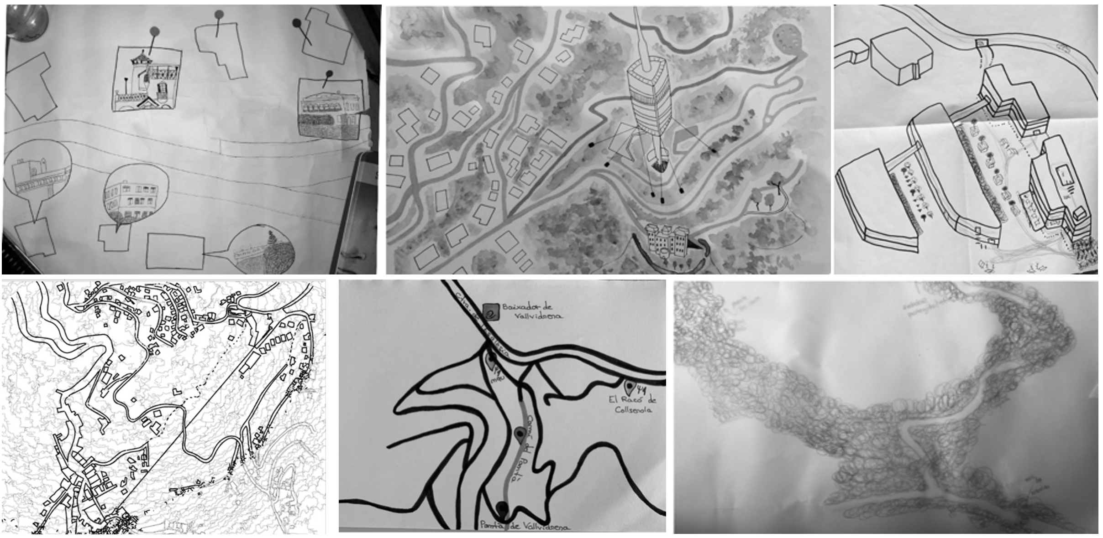
Figure 2. Examples of sensory mappings by students from EINA University School of Design and Art of Barcelona, 2022.

One student described their discovery process saying, “When I ventured alone into Collserola, although a bit terrified by the strong wind, it led me to an unexpected experience. As it was windy, you could hear the wind blowing through the leaves, but, due to the forest's density, you could hear it before it arrived. I carried this experience with me for a long time later. Then I started making the cartography based on these small spaces or surprises that I was finding” (Zaira Soler, 2022). This student’s experience shows the transformative power of immersed exploration and individual perception in understanding complex environments, that was later explored in possible future hypothesis, the second part of the methodology.

3.2 Activity #2: Speculating on Possible Futures
The next activity proposed to students was the introduction of a taxonomy of uncertainty through thought-provoking questions to anticipate and imagine the park's future in 100 years. Rather than “succumbing to sugar-coated optimism or paralyzing pessimism in the face of these complex challenges” (Archer-Martin and Stokes, 2023, p. 185), our effort was to join voices with those who embrace a “possibilist” mindset and ways of being with uncertainty (Ichioka and Pawlyn, 2021, p. 15). Within uncertainty, students could see an opening to a pluriverse of possibilities, a “world where many worlds fit” (Escobar, 2018, p. xvi). These possibilities emerged from co-creative processes of futuring, in which we all students participated as separate but intertwined roots of the human-nature whole experienced at the Collserola Park.
First questions addressed social, economic, environmental, and technological shifts, encouraging students to imagine desired legacies, societal structures, and potential challenges for the areas they sensorially explored in the first activity. Following this imaginative exercise, students were stimulated to use the proposed framework model (Table 1) to generate speculative concept hypotheses, articulating both “what” (the future scenario) and “why” (its rationale).

Table 1. Framework model for speculative hypothesis generation. Prepared by the author, 2022.
IN A [?] FUTURE |  | THERE’S A [?] |  | RELATED TO [?]
Beautiful  Brilliant  Creative  Decolonized  Just  Fast  Feminist  Solidary  Global  Green  Technological  Cheerful  Innovative  Happy  Open  Affectionate | Black  Fun  Queer  Reactionary  Resistant  Sad  Selfish  Intelligent  Sustainable  Exciting  Volatile  Wild  Wise  Hot  Mystical | Building  Instrument  Device  Disaster  Festival  Flag  Food  Game  Piece  Invention  Work  Kit  Manual  Machine  Map  Mask | Monument  History  Organization  Toy  Product  Public service  Ritual  Song  Route  Tattoo  Tool  Video  Clothes  Public space  Archive  Place | Animals  Cities  Climate change  Death  Economy  Education  Energy  Natural environment  Family  Agriculture  Genetics  Governance  Health  Identity  Neighborhood  Roots  Elderly | Superstitions  Ground  Science  Space  Music  Spirituality  Home  Transport  Dialogue  War  Walk  Food  Water  Art  Childhood  Cure  Migration  Furniture | Imagination  Justice  Leisure  Love  Residue  Ocean  Creation  Feminism  Heritage  Experimentation  Seasonality  Territory  Listen  Touch  Mountain  Culture  Urbanism  Agriculture

By combining these ones or their own keywords, students started putting together themes, opportunities and scenarios for the areas walked during the previous practice. We guided them away from certainty/uncertainty binaries and toward relational, pluriversal paradigms, acknowledging uncertainty as a fundamental condition of ethical cross-cultural partnerships. Inviting students to contribute their own “what if...?” hypothesis, this pluriverse of possible futures ignited imagination and agency. These first possibilities of interaction were further explored formally in the next phases of the project (Sections 3.3 and 3.4).
3.3 Activity #3: Brainstorming with AI
The recent influx of AI image generation tools like Dall-e and Midjourney has opened the door to a plethora of visual creations that are already being field-tested by architects and designers for use in conceptual design, allowing them to explore a wider range of design ideas from a new perspective in a free and easily accessible tool (Yildirim, 2022; Ploennings and Berger, 2022). Acknowledging this reality, the third pedagogical activity explored AI’s potential to test its limits and possibilities in the creative process, while enabling students to visualize their hypothesis, and overcome the fear of the blank page. We were not looking to replace drawing, model making, computer-aided design (CAD) tools, rendering or any of the other basic skills that industrial designers use. But rather, we wanted to question students how AI could be used to enhance each their design process, or perhaps, how it could be used to avoid hitting creative blocks.
After discussing the ethical considerations and creative possibilities, students engaged in simple demonstrations, prompting the AI with whimsical ideas like “A painting of rapid climate change by Leonardo da Vinci” or “Realistic photo montage of Barcelona, showing grey sky, depicting the rising sea level and the water engulfing everything, submerged homes and destroyed infrastructure of beaches”. This generated unexpected stories, visual forms, pushing them beyond their traditional drawing boundaries and sparking new ideas.
The key focus was on channeling the sensations they wanted to evoke in their final design and engaging in playful exploration, fiction, humor, and artistic references. This fostered the development of design poetics within each project. Prompts would range from “an object that represents where self-destructive humanity goes” (Figure 3.a), “futurist viewpoint in a tower on the mountain overlooking the city in 2100”; (Figure 3.c) to “a photo of object that can survive 100 years over a hill with flooded Barcelona in the background” (Figure 3.d).
Students embraced the AI exploration in diverse ways, as illustrated by a few students in Figure 3. Some used the generated images as a form-finding tool to expedite or augment their existing process. Others sought to envision future projections for their chosen intervention sites. Still others discovered that the AI nudged them in unexpected design directions, sparking creativity and innovation. Notably, while most of the students found AI tools valuable, some preferred their usual working traditional methods such as drawing or 3D modeling, suggesting personal preferences and existing skillsets that may not align with every digital tool. Finally, after extensive explorations with AI tools, the students returned to hands-on work, elaborating drawings and models of their proposals (as described in Section 3.4). Overall, each of the 25 projects contributes its own perception of the city and the forest, promoting pro-environmental behaviors based on embodied, situated, and affective approaches to cognition. To gain deeper insights, we explore three specific projects in detail in the next section.

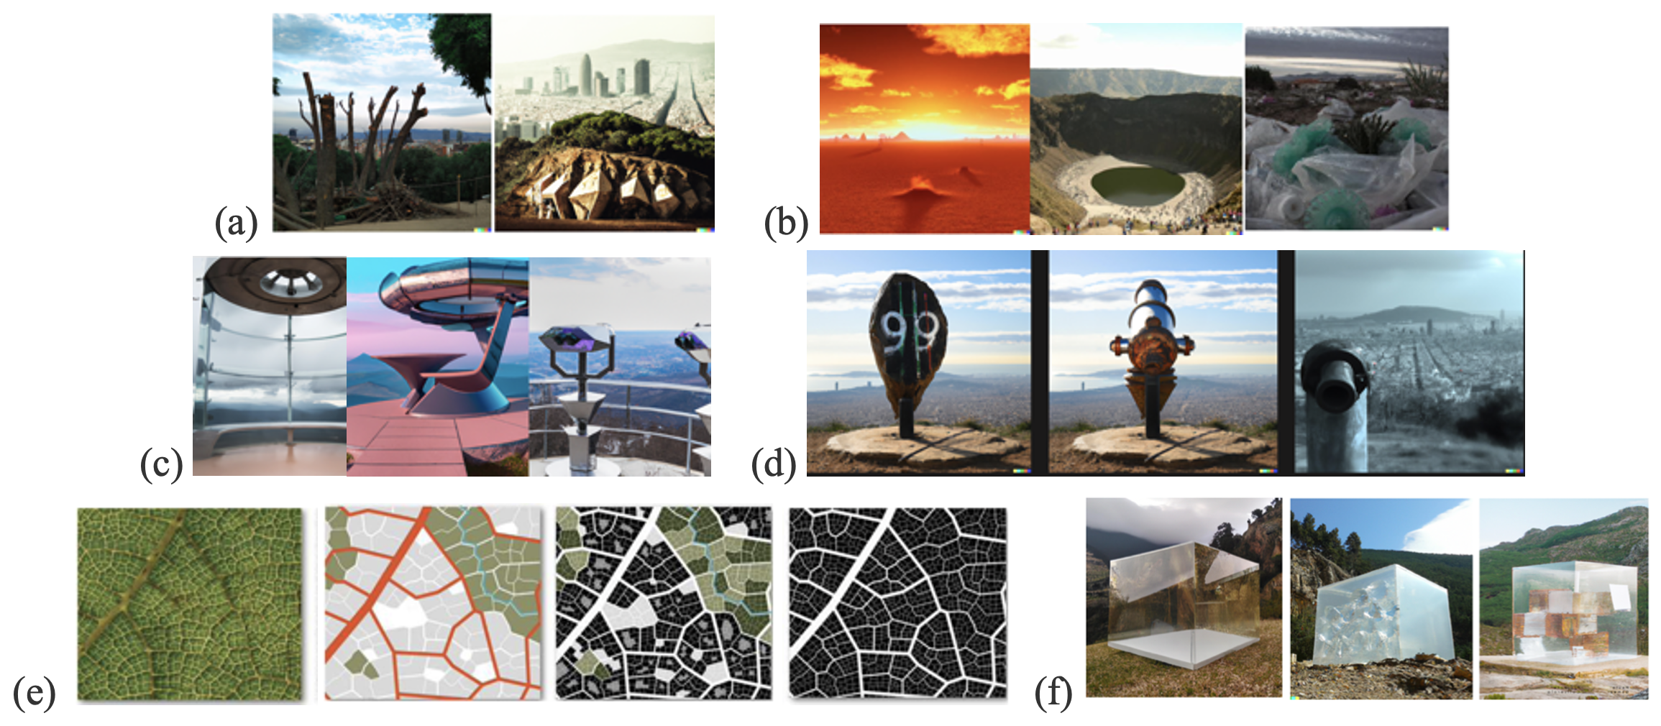
Figure 3. Selection of explorations with Artificial Intelligence created by six of the 25 students for the discipline Projects I at EINA University School of Design and Art of Barcelona, 2022.

3.4 Activity #4: Drawings and Materialization
After analyzing the AI-generated images, the last phase of the pedagogy was to formalize their concepts, resonating with their chosen scenario. They used sketches to further develop their hypothesis, eventually materializing them into physical prototypes using either handcrafted techniques, 3D modeling or digital fabrication tools. Figure 4 illustrates an array of proposed interventions within the Collserola Natural Park. These 25 projects ranged from experimental sculptures and sound devices to proposals for buildings, repurposed spaces, and urban furniture to the community.
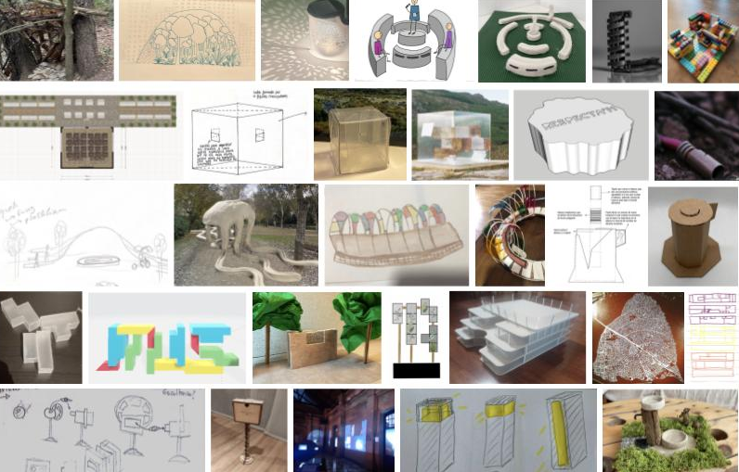
Figure 4. Samples of the 25 students’ projects proposed for the discipline Projects I at EINA University School of Design and Art of Barcelona, 2022.

Each proposal was rooted in the student's affective experience gathered during their exploration in the park, while simultaneously aiming to generate ethical and sustainable contributions for both humans and non-humans inhabiting the area. Several students explored different formulations for the concept of “memory” through their proposals. Some aimed to capture and preserve elements of the present or past, ensuring they stay alive even 100 years into the future. Others tackled present-day issues and challenges, offering concrete solutions with an eye towards improving the park's state for future generations. In the next section, we will broadly discuss its results and detail three of these 25 case studies.

4. Results
To evaluate the effectiveness of our pedagogy, we analyzed the student projects with an emphasis on both individual and collective processes and outcomes, and the relational impact within the Collserola Park natural surroundings and community. Focusing on ecologic consciousness, experimentation, and agency, we looked for indicators of how students navigated uncertainty as a “fundamental condition of ethical partnership” (Archer-Martin and Stokes, 2023). To our surprise, evidence of success did not appear in the way we expected, which is indeed the purpose of such creative processes aimed at producing new knowledge. The case studies selected below illustrate our own transformational learning and paradigm shift. Where the workshop was most successful in enhancing planetary thinking and agency was in relation to climate change, and in producing outcomes that were socio-culturally restorative, ecologically regenerative, or both. This notion was embodied, for example, through the emergence of public installations formed around water crisis awareness and by the ultimate considering humans and non-humans.
Where our pedagogy initially appeared less successful was in demonstrating engagement with local community knowledges through the project. Many of the works did not explicitly engage with or include natural materials from the area, neither representations of the natural fauna, flora or Catalan community hence 100 years. One reason might be that students were in their first semester, therefore at an initial phase of their design formation, where notions of recycling, sustainability or community are not yet present in their creative process mindset. Students, therefore, were not fully ready or equipped with the tools necessary for creating solid regenerative and ethical work. This may point to a broader deficit in the design curriculum, but may also indicate indirect learning as part of a learning ecology. Ultimately, this revealed a misguided assumption that ethical engagement with materials and community should be explicit in the outcomes guidance in first place, that should be considered by educators. Having said that, in the next session we present a selection of three outcomes out of the 25 proposals that encompass the diversity of explorations conducted by the students.

4.1 A Glimpse into the Future: Bygone Waters
Following the Carretera de las Aguas, a scenic route overlooking Barcelona, student Pedro Figuereo mapped out the places from where meanders could see Barcelona’s sights (marked in green in Figure 5a). For the development of the project, he envisioned two potential interventions. One, contemplative and sculptural, turned away from the city towards the forest. The hypothesis of Barcelona losing significant coastal land due to rising sea levels in 100 years was tested using Dall-e, generating an image that captured the essence of this concept (Figure 5d). The other proposal offered an interactive experience directly facing the city from a privileged vantage point on Collserola mountain.
Driven by these ideas, the student created “Aguas Pasadas” (Bygone Waters, Figure 5), a sculpture that explored the volatility of the sea level changes related to climate change in a dystopic future. The project aimed to raise awareness about the future consequences of our current unsustainable practices. Inspired by existing binoculars found at viewpoints, the student designed an installation combining them with a 3D viewer and slides. Each slide, filtered to depict rising sea levels and changing cityscapes, presents the user with a glimpse of Barcelona in 10, 20, or even 100 years. This immersive experience prompts reflection on the city we want to preserve and remember.
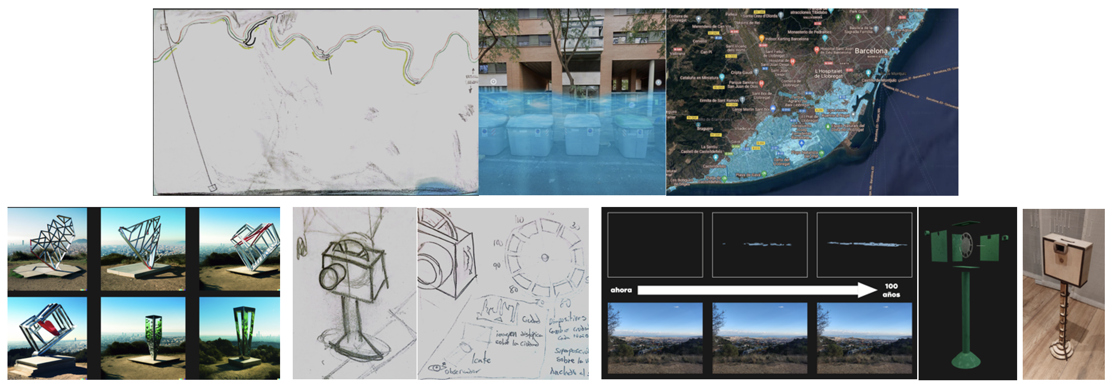
Figure 5. Pedro Figuereo. Hypothesis of Barcelona's flood and research with AI tool Dall-e: “Photograph of a large, polygonal methacrylate object inspired by the potential self-destruction of civilization, situated on a hill overlooking Barcelona in the background”; drawings and model for Bygone Waters project. From the binoculars, users would see the water levels over Barcelona and could change the number of years to see the flooding progress. 2022.
4.2 A Fountain for All: Humans and Animals
Student Carolina Abelleyro’s project focuses on the Vallvidrera Reservoir, built in the 19th century but neglected for much of the 20th century before its 2006 refurbishment (Figure 6a). Upon arriving, the student observed the reservoir's low water level and lack of people, contrasting with the abundance of animals. This stark reality inspired the hypothesis of, in a post-human and ever-drier future, a public drinking fountain could address both the future water scarcity and the needs of non-human inhabitants. Envisioned as a place where humans can drink and animals can bathe, the fountain of the swamp considers the challenges of climate change, such as high temperatures and limited rainfall.
The student designed a water-repellent wooden structure that blends seamlessly with the surrounding trees, minimizing visual impact and human footprint. The fountain utilizes a scale system similar to a toilet flush: a cement platform triggers water flow for four-legged animals, while a separate platform on the basin floor serves birds. A human tap is conveniently located on the other side of the trough, maintaining hygiene and accessibility for all users. The student emphasizes the use of a thermal cement coating for the clay components. This coating ensures the material remains cool, non-absorbent, and slipresistant, providing a safe and comfortable experience for animals using the fountain.
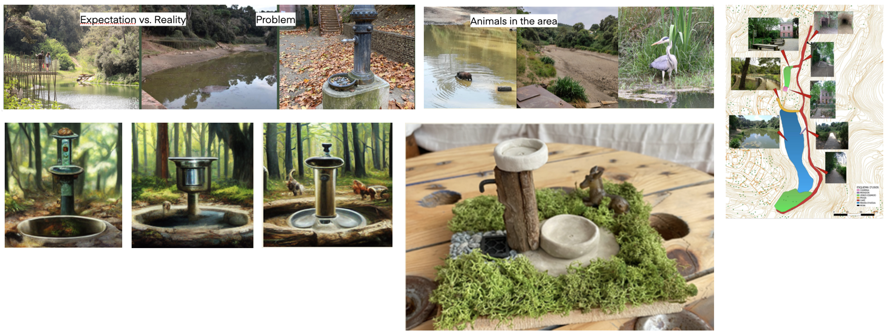
Figure 6. Carolina Abelleyro, Expectation and reality comparison; fountain which is not accessible to animals in the Vallvidrera Reservoir; map with walking paths and animals; research with Midjourney with prompt “A fountain where people, earth animals and birds can drink and animals can bath integrated in the middle of the forest”; mock-up of the fountain for humans and non-humans. 2022.
4.3 Illuminating, Remembering, and Preserving: The Calloway Project
Students Elisabeth Boix and Martí Forcada explored the evolution of the stairway connecting the Peu de Funicular with the Montserrat School (Figure 7). Originally a stream, it transformed into a footpath and later stairs with a funicular. While the surroundings haven’t changed much since 1897, the streets and particularly the foundations, gradually replacing old sand roads, reveal the passage of time. Based on this data, the hypothesis formulated to speculate on possible futures for that area was that in a gentrified, waste free and urbanized future, there was going to be a spatial element that would remind visitors and locals about the heritage and history of the neighborhood.
Focusing on areas with poor lighting, especially in the mountain section, the students proposed an outdoor light installation. This light serves two purposes: providing illumination for safe passage and drawing an analogy to the historical stones of the pathway. The materials reflect this theme: recycled plastic waste represents the modern era, while cement symbolizes the evolution of asphalt. The stencil is used as a light filter, resulting in a projection that transforms a staircase’s concrete into cobble stone.

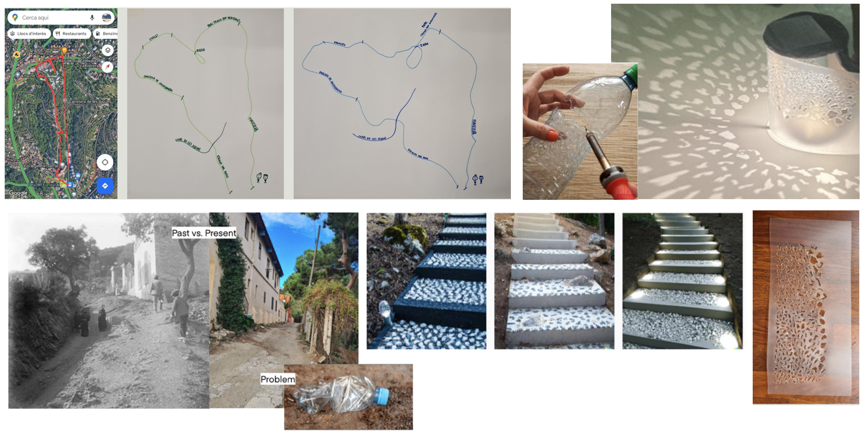
Figure 7. Elisabeth Boix and Martí Forcada. The surprising unrelation between Google Maps and the two cartographies that illustrate the memories and routes taken by students in the Collserola; photographic research (1897-2022); speculations with AI tool Dall-e with prompt “Light stairs forest gravel plastic concrete”; Process and final model of the Calloway lamp. 2022.
5. Discussion and Contributions
This project stands out for its significant contributions to design education and research. As western academia and typical pedagogical approaches often discourages students from introducing such explicit subjectivity into their work (Archer-Martin and Stokes, 2023, p. 192), the workshop’s core tenets lie in showing the value of empirical and sensory experiences in design. This contributes more broadly to psychogeography methods and to challenge preconceived notions of space and perception. This approach, combined with life-centered, speculative and future-oriented design tools, weaves together to create a powerful pedagogical methodology that equips aspiring designers with skills to envision possibilities that adopt diverse positions and perspectives on self, others and world. Moreover, it might advance discussions around the influence of the ecological crisis in the future of the design profession, to act agentically and discover possibilities within constraints (Glăveanu, 2020). In short, the presented pedagogy:
- Promotes Sustainable & Critical Thinking: This project successfully shows the value of incorporating walking experiences, experiential futures and speculative design into design education and research. It demonstrates how these approaches can stimulate creative thinking, foster deeper and embodied understanding of space, and encourage exploration of alternative, potentially more sustainable or disruptive futures.
- Challenges Spatial Determinism: By prompting students to move beyond traditional interpretations of space and engage with sensory mapping and speculative design, this project pushes against rigid design practices. It encourages considering both human and non-human needs, leading to more inclusive and speculative design solutions.
- Explores Sensory Maps & AI as Design Tools: While not a replacement for core design skills, sensory maps and AI have the potential to enrich the creative process. This project showcases how they can help designers gather data, generate ideas, and explore diverse possibilities in a shorter amount of time, ultimately leading to experimental and nuanced proposals. The workshop arised from the praxis, the empirical, the sensorial and the unexpected.
Having said that, the change of mindset, which was a desired outcome of this workshop, cannot by its very nature be achieved in the short term. The workshop did, however, inspire action and stimulate new perspectives and immediate reflections on the issues at stake. Comments from some of the students who took part in the pedagogy demonstrate this reflection: “I can see more and more clearly the need to create spaces of connection with nature. I start from the selfish future situation that has destroyed the forests and has become completely urban. Because just as in the forest you can hear the sound of the wind before it arrives, we must be able to see our reality, before there is no return.” (Zaira Soler, 2022); “In a hundred years, I would like the feeling of community and togetherness to become important, so that we can create great projects to help the planet and combat climate change.” (Carlos Balmes, 2022). Also implicit in these notes is the important role of design discourse, which must also take advantage of its phenomenological capacity, going hand in hand with hermeneutics and experimentation.
6. Conclusions
This workshop extended beyond being simply a learning experience or research endeavor. Its impact resonates deeply within the realm of design education, showing the potential of innovative pedagogical approaches. By incorporating walking, experiential learning, and speculative design practices, this project contributed significantly to the evolution of design education and prepares future designers to tackle the complex challenges of our time. “Take the Memory Out for a Future Walk” was born out of the innate human need to walk and preserve. In addition, it explored a speculative perspective of design as the embodiment of landscapes. Some key findings and lasting impacts are:
- Learning & Growth: Despite initial challenges and limited time available to develop their solutions, students valued the project for its experiential learning opportunities and imaginative exploration. This suggests that such methods can motivate and engage students while equipping them with essential design thinking skills.
- Understanding through Experience: The act of walking, drawing, and speculating proved to be powerful tools for understanding reality and shaping visions of the future. This reinforces the importance of incorporating these activities into design education to cultivate critical thinking and design agency.
- Students Perspectives: The projects provided valuable insights into the concerns and aspirations of the new generation of designers. The students’ focus on community, connection to nature, and environmental responsibility reflects a growing awareness of these crucial issues and emphasizes the need for design solutions that address them.
- Research amplitude: By fostering reflection and promoting the formulation of new perspectives within the realm of design and possible futures, the work emerges as a relevant object of study in the academic sphere, offering ample opportunities for in-depth analysis, debates and investigations, besides concept development.
Based on student feedback and observations, future iterations could benefit from different approaches to be further considered. Firstly, an increased time dedicated to walking, mapping, and gathering sensory data could lead to even richer understanding and more nuanced life-centered design propositions, including solutions related with accessibility, ethics or social inclusion. In addition, the adoption of natural, recycled or reused materials found within the park could foster environmentally conscious design practices and encourages deeper engagement with the specific context and should be considered in future explorations. Lastly, while AI tools offer valuable creative and speculative opportunities, limiting their use could promote reliance on core design skills and encourage critical exploration of their potential benefits and limitations. Notably, the proliferation of computer-aided design (CAD) or AI-based tools might overlook the intrinsic vitality of imperfection and the unexpected, whose reflections underscore the dynamism inherent in imperfect forms. Thus, a critical reevaluation of the relationship between technological precision and human expression is imperative to mitigate the alienation precipitated by digitalization, reaffirming the centrality of embodied creativity within design pedagogy.
Finally, the relationship between location, time, nature, and creativity should also be acknowledged. By challenging spatial determinism when focusing on 100 years forward, the workshop can contribute significantly to education’s evolution and help prepare future designers to address the complex challenges of our time and deal with uncertainties and possibilities. As Ichioka a Pawlyn state “the necessary changes lie primarily in cultural, rather than technological, transformation, and that this must occur at the level of mindsets – the shared ideas that determine to a large context how society works” (2021). Identifying the future we desire, communicating it more concisely and assertively, living it in the work we do, sharing this knowledge, and doing it again, better, are all steps in the change-making process that can promote a critical formulation of future-oriented projects. The success of this methodology will lie on its ability to extend its reach and the way it is embraced, understood, and promoted by other students, educators and researchers. In this sense, a shift in consciousness towards a more sustainable future is a gradual process, not achievable within a short timeframe, nor by the efforts of a single individual or artistic endeavor alone. Such a transformation requires a disciplined approach across various domains, along with the initiatives and proposals it inspires. In this context, the workshop represents a beacon of hope for the future.

Acknowledgements
I want to express my gratitude to EINA University School of Design and Art in Barcelona for the opportunity to design and conduct this workshop at the institution. I also want to thank the students from the Projects I course (2022-2023) in the Bachelor of Design program for their dedication and for making their work available for this research.

References
Abrahamse, W., Matthies, E. (2018). Informational Strategies to Promote. Pro-Environmental Behaviour: An Introduction. DOI: 10.1002/9781119241072.ch26.
Alves, L. P., Pérez, C. L. (2018). Erratic lines: cartographies of another way of existing in (life and) school. Childhood & Philosophy, 14(31), 575–594. DOI: 10.12957/childphilo.2018.36041
Archer-Martin, J., Stokes, G. (2023). Whakamana: Embracing Uncertainty in Relationally Responsible Spatial Design Studio Pedagogy for a Flourishing Aotearoa. Idea journal 20 (01):183–204. DOI: 10.37113/ij.v20i01.513
Auger, J. (2013) Speculative design: crafting the speculation. Digital Creativity, 24:1, 11-35. DOI: 10.1080/14626268.2013.767276
Berger, J. (2005). Berger on Drawing. Occasional Press.
Berry, T. (1999). The Great Work: Our Way Into the Future. Bell Tower
Bullen, D., Fox, J., Lyon, P. (2016). Practice-infused drawing research: ‘Being present’ and ‘making present’. Drawing: Research, Theory, Practice, 2(1), 129-142. DOI 10.1386/drtp.2.1.129_1
Busto, M.; Yzaguirre, X. de. (2024). Consequences of three years of drought in Catalonia. EGU General Assembly 2024, Vienna, Austria, 14–19 Apr 2024, EGU24-18358. DOI: 10.5194/egusphereegu24-18358
Candy, S.; Dunagan, J. (2016). The Experiential Turn. Human Futures. 26.
Carey, H., Arredondo, R., Bansal, M., Costes, C. (2022). Envisioning New Futuring Models: Past, Plurality, and Positionality. In: Bruyns, G., Wei, H. (eds) [ ] With Design: Reinventing Design Modes. IASDR 2021. Springer. DOI: 10.1007/978-981-19-4472-7_244
Certeau, M. de. (1984). The Practice of Everyday Life. University of California Press.
Debord, Guy (1981 [1958a]) Theory of the dérive, in Ken Knabb (ed. and trans.) Situationist International Anthology. Bureau of Public Secrets, pp. 50–4.
Downs, R.M., Stea, D. (1973). Image and environment: cognitive mapping and spatial behavior. Aldine Publishing Company.
Dunne, A., Raby, F. (2013). Speculative everything: design, fiction, and social dreaming. Mit Press.
Escobar, A. (2018). Designs for the Pluriverse: Radical Interdependence, Autonomy, and the Making of Worlds. Duke University Press.
Espinheira-Gomes, R. (2024). Listen and be the space: exploring space, word, and music in architecture and architectural discourse. Revista de Arquitectura, 29(46), 10-30. DOI: 10.5354/0719- 5427.2024.73574
Evans, D. (2013) The Art of Walking: A Field Guide. Black Dog Publishing London UK
Glăveanu V. P. (2020). The possible: A sociocultural theory. Oxford University Press.
Gómez Molina, J. J.; Cabezas, L.; Copón, M. (2005). Los Nombres del Dibujo. Ediciones Cátedra.
Goulet-Pelletier, J.C., Cousineau, D. (2024). The Creative Space Theory as a map to explore the mind. Possibility Studies & Society, 2(1), 77-106. DOI: 10.1177/27538699241233195
Kholina, A. (2019). Maps, space and body: connecting mental representations of space to the production of space. RUUKKU - Studies in Artistic Research, 10. DOI: 10.22501/ruu.452508
Ingold, T. (2000). The Perception of the Environment: Essays on Livelihood, Dwelling and Skill. Routledge.
Ingold, T. (2010). Footprints through the weather-world: walking, breathing, knowing. The Journal of the Royal Anthropological Institute, 16, S121–S139. Available at: http://www.jstor.org/stable/40606068 (accessed 8 March 2024).
Jawaharlal, M., Ellingwood, S., Thokchom, K. (2016). Life Centered Design Using Morphological Chart. Proceedings of the ASME 2016 International Mechanical Engineering Congress and Exposition. Volume 11: Systems, Design, and Complexity. Phoenix, Arizona, USA. November 11– 17, 2016. V011T15A026. ASME. DOI: 10.1115/IMECE2016-65121
Lydon, M., Garcia, A. (2015). Tactical urbanism: Short-term action for long-term change. Island Press. DOI: 10.5822/978-1-61091-567-0
Merchant, C. (2013). Reinventing Eden: The Fate of Nature in Western Culture. Routledge.
Merchant, C. (2020). The Anthropocene and the Humanities: From Climate Change to a New Age of Sustainability. Yale University Press. DOI: 10.2307/j.ctvzpv6xj
Morton, T. (2021). All Art is Ecological. Penguin Classics.
Ichioka, S., Pawlyn, M. (2021). Flourish: Design Paradigms for Our Planetary Emergency. Triarchy Press
Pallasmaa, J. (2009). The Thinking Hand: Existential and Embodied Wisdom in Architecture. Wiley.
Ploennigs, J., Berger, M. (2022). AI Art in Architecture. arXiv preprint arXiv. DOI: 10.48550/arXiv.2212.09399
Portella, G. (2024). Slow drawing: drawing for a contemplative path. [Doctoral thesis, University of Lisbon]. University of Lisbon, Faculty of Fine Arts. https://repositorio.ul.pt/handle/10451/64471
Rossetto, T. (2019). Object-Oriented Cartography: Maps as Things. Routledge.
Seguí, J. (1999). Drawing what cannot be touched. EGA: revista de expresión gráfica arquitectónica (5), 39-50.
Skaza, M. (2019). Architecture as a Consequence of Perception. IOP Conference Series: Materials Science and Engineering, 471. IOP Publishing Ltd.
Smith, R. T. (2016). Blind Drawing: A Disruption of Perfectionism. Tracey Journal, 11(S.I), 1-22.
Sumarjoto, S.; Pink, S. (2019). Atmospheres and the Experiential World: Theory and Methods. Routledge.
Yildirim, Erdem. (2022). Text-to-Image Generation A.I. Art and Architecture: Theory, Practice and Experience. Livre de Lyon.

